
The Rotary Club of Wilmington, Delaware
Celebrating over 100 Years of Fellowship and Service
ISSUE 15 2016-2017 OCTOBER 20 – OCTOBER 27

UPCOMING PROGRAMS

October 20
John Aucott, Director
Johns Hopkins Lyme Disease Research Center
Program Chair: Matt Beardwood
Menu: Pan-Seared Chicken with Lemon and Capers Sauce
October 27 – RCW, 2016-17 Community Service Project/Stubbs Elementary School
Community Partners Facilitated by Susan Polikoff
Program Chair: Susan Polikoff
Menu: Brown Sugar Baked Ham with Glazed Yams


New Member – Kia Ervin
Proposer: Yasser Payne
Seconders: Will Minster, Sarah Brown
Kia Ervin is a branding expert with over a decade of experience. She specializes in developing unique opportunities for industry leaders in a myriad of professions including sports, entertainment and politics. Her work expands their brand by developing strategic partnerships and increasing their philanthropic engagement. As a native of the Washington DC area, Kia became actively engaged in dance and youth programs where her love for entertainment and her passion for social justice began at a young age. Her work as a social change agent has continued as a prominent theme throughout her career. Kia is the Executive Director of Accelerate Delaware, a subsidiary of The Longwood Foundation. She is responsible for retaining millennials in Delaware by creating a community where young professionals engage in meaningful relationships that advance social, civic and professional growth. Kia obtained a Bachelor’s degree in Public Relations, a Master’s degree in Counseling and is pursuing a graduate certification in Non-Profit Management from Harvard University. Known for her passion, integrity and creativity, she is committed to being a life-long learner with relevant impact globally. She enjoys traveling, good conversation, delicious food and wine and creating priceless memories with her family and friends.

STOP HUNGER NOW – SATURDAY, OCTOBER 15, 2016
FROM START TO FINISH – WHAT A GLORIOUS WAY TO START THE DAY
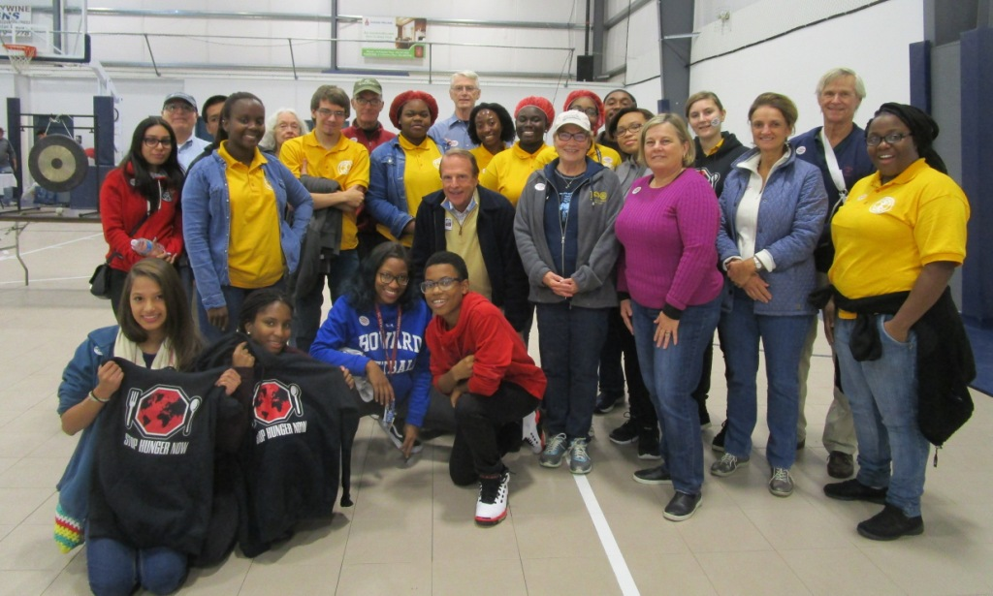
Interactor students and Rotary members – Job Well Done!

Minutes for Meeting of October 13, 2016
President Kai Lassen called the meeting to order at 12:10pm at the Hotel du Pont’s King & Sullivan Rooms. The Club joined together in reciting the Pledge of Allegiance led by Anne Eidschun. Rich Williams provided the invocation.
Announcements: President Kai welcomed several guests. President Kai reported that the Can-Do Playground Clean Up on Saturday, October 8th was successful. He thanked the following volunteers: John Callahan; Ted Geist; Bill Jeremiah and his daughters, Baker and Mallory; Ralph Marshall and his wife, Stephanie, and their son, Jack ; Cynthia Morgan; Steve Novack and his wife, Pat; and Interact Club members Kayla Davis, Sarena James, and Destinee Lampkin. President Kai called on numerous club members who made the following announcements: Pam Cornforth – volunteers are needed for Stop Hunger Now, Saturday, October 15 as early as 7:30am for set up and the event begins at 8:30am; Ralph Marshall – Rotarians and guests are invited to “Coffee Talk” on Wednesday, October 19th from 8:00 – 9:30am at the Greenville Brew HaHa!; Dave Fleming – please send program ideas for the third and fourth quarter to Dave and/or Program Committee members, ideally prior to their committee meeting scheduled for October 27th; President Kai – there is one opening for Rotary Leadership Institute on Saturday, October 22nd and please contact Sue if you are interested; and President Kai – charitable contribution letters were mailed last week and please return them as soon as possible. President Kai mentioned details of upcoming meetings: John Aucott, Director, Hopkins Lyme Disease Research Center on October 20 and the 2016-2017 Community Service Project at Stubbs Elementary – mark your calendars, please!
Program: Bob Reardon provided the introduction of the speaker, Paul R. Flora, Senior Economic Analyst and Research and Policy Support Manager, Philadelphia Reserve Bank. Paul’s presentation was titled ‘National and Regional Economic Update,’ and he offered his perspective on the economy with the club. He mentioned that the Gross Domestic Product (GDP) is the best measure of our economic activity and it is not the best indicator of economic health. He explained that occurrences such as natural disasters (most recently Hurricane Matthew), increased divorce rates, and pollution create more spending, but are not necessarily viewed as healthy to our economy. Our nation’s GDP has slowed lately as a result of the nation nearing full employment and the increase in labor wages. Nationally, we are not in or close to a recession, but our six energy states (i.e., Texas, Alaska, Louisiana) have been in a recession since 2015. Overall, consumers are better off financially, food prices are down, and these are good signs. GDP tends to be strong when there is population growth.
Paul shared a variety of economic forecasts, and the sources for these forecasts were primarily courtesy of BEA via Haver Analytics and FRB Philadelphia SPF. GDP forecasts are as follows: 2016 Q2 – 1.4%; Q3 – 2.6%; Q4 – 2.3%; 2017 Q1 – 2.3%; Q2 – 2.3%, and Q3 – 2.1%. The 2016 annualized GDP is predicated to be 1.8%. Regarding national employment and income forecasts, employment has been slowing down the past two years, which is a direct result of the nation nearing full employment rates. Year-Over-Year payroll employment growth rates are: New Jersey – 1.3%; Delaware – 2.7% (strong); Pennsylvania – 1.0%; and National – 1.7%. Delaware has seen more growth in the manufacturing sector and lower growth in the financial sector the past several years. Paul reported the following Unemployment Rates for 2016: Delaware – 4.3%; Pennsylvania – 5.7%; New Jersey – 5.3%; and National – 5.0%. The 2014 – 2015 State Median Household Income for Delaware rose 2.5% compared to the National increase of 3.8%. The National foreclosure activity rate is 1.1%, down slightly over the past few years, but still higher than the three decades prior to the 2008/2009 housing crisis. The National inflation rate is 1% compared to the ideal rate of 2%, which is generally a good rate to target. An inflation rate that hovers around 0% is dangerous and a high rate causes volatility in the economy. There is a 17.3% prediction that interest rates will rise in November and a 64.3% predication that they will rise in December. Overall the global economy is weak, and Paul cited government (i.e. China, Japan, Greece), exports, imports, and businesses/investments as contributing factors. For more economic data: https://www.philadelphiafed.org. Committees to meet after the meeting: None The meeting ended at 1:30 pm. Respectfully submitted, Cindy Campanella, Secretary
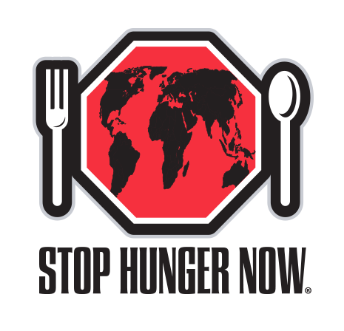
34,000 MEALS IN 2 HOURS
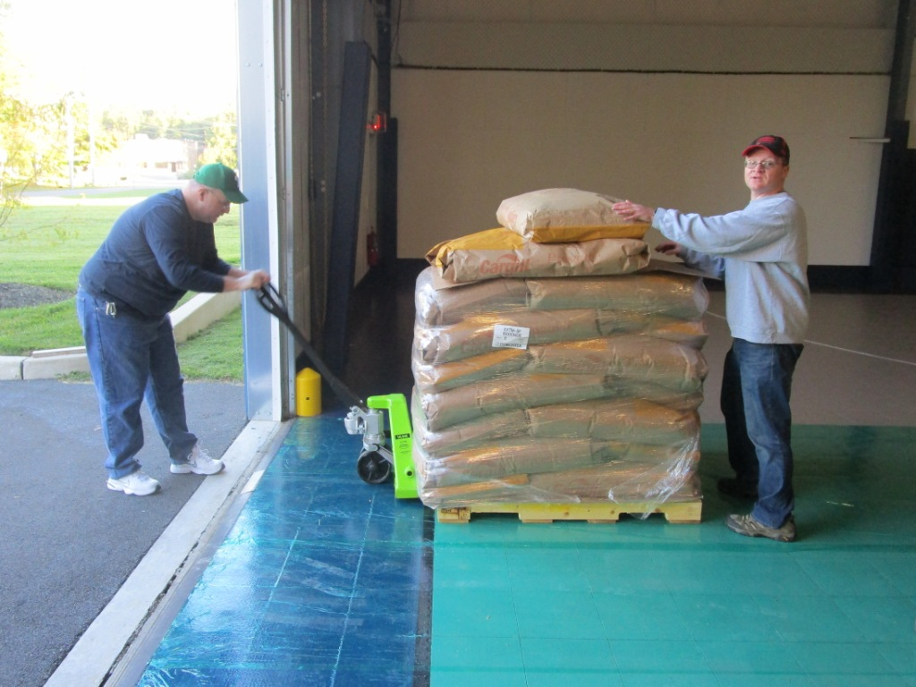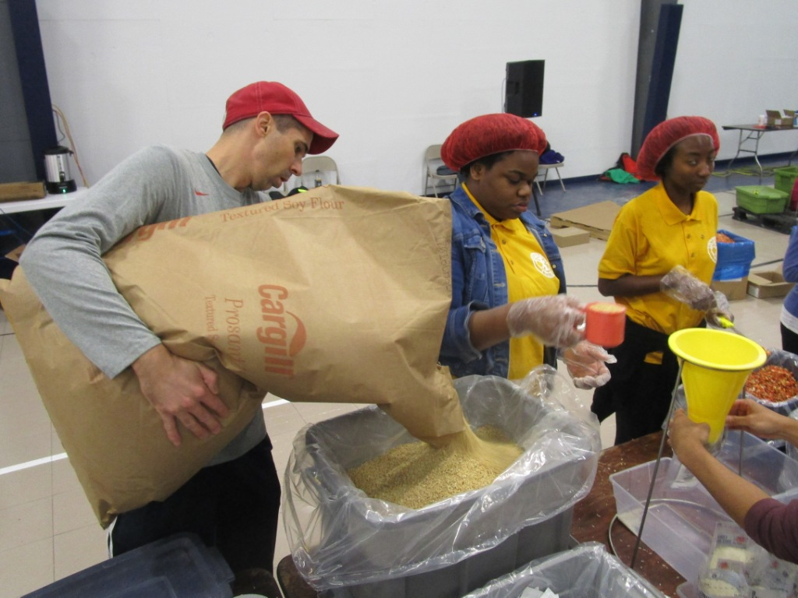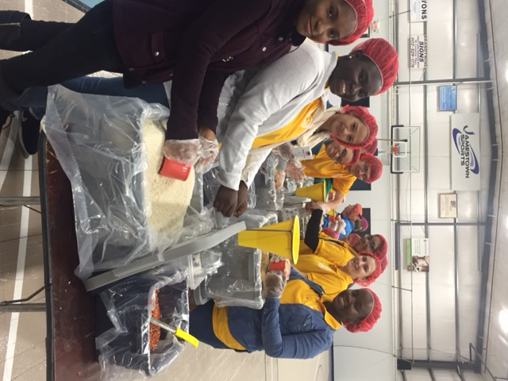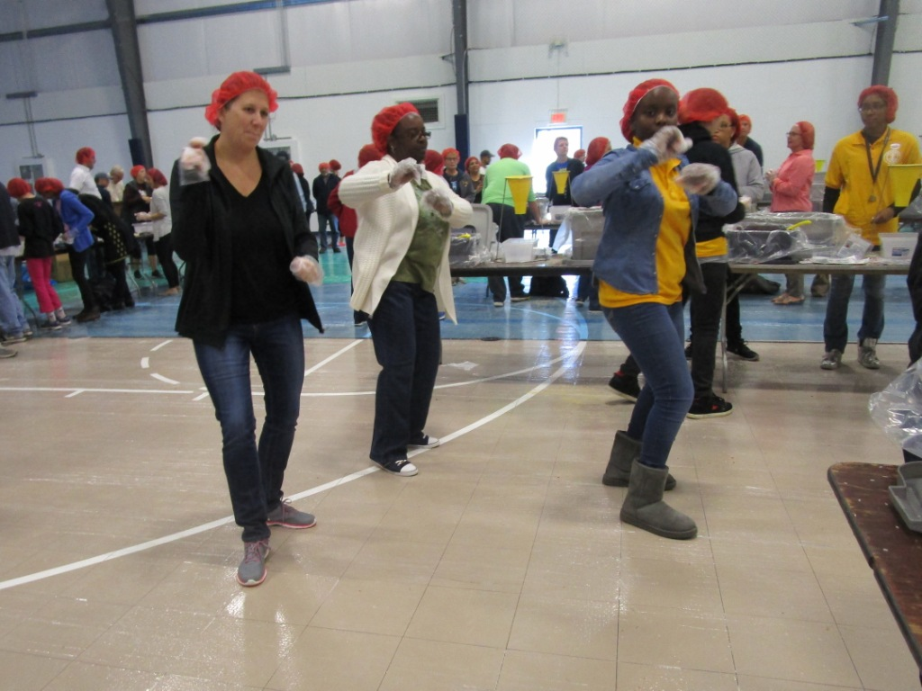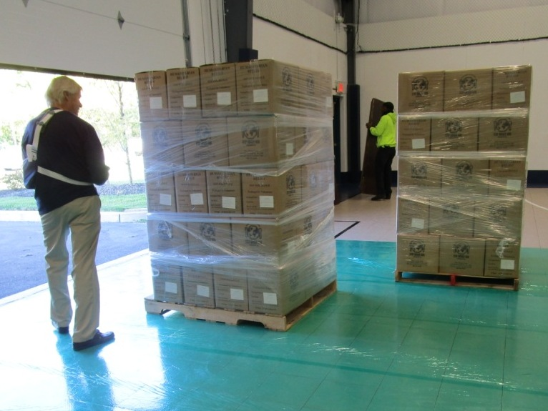
START TO FINISH
COMMITTEE MEETINGS / DATES / EVENT
October 22 Rotary Leadership Institute, North East, MD, 8:30-4:30
October 27 Program Committee
November 12 Family Fun, 87ers, UofD, 6pm
November 19 Rotary Foundation Dinner, Dover, 5:30pm

