
The Rotary Club of Wilmington, Delaware
Celebrating over 100 Years of Fellowship and Service
ISSUE 14 2016-2017 OCTOBER 13 – OCTOBER 20

UPCOMING PROGRAMS
October 13
Paul R. Flora, Research & Policy Support Manager
Senior Economic Analyst, Philadelphia Federal Reserve Bank
Program Chair: Bob Reardon
Menu: Eggplant Parmesan
October 20 – John Aucott, Director, John Hopkins Lyme Disease Research Center
Program Chair: Matt Beardwood
Menu: Pan-Seared Chicken with Lemon and Capers Sauce
October 27 – RCW, 2016-17 Community Service Project/Stubbs Elementary School
Community Partners Facilitated by Susan Polikoff
Program Chair: Susan Polikoff
Menu: Brown Sugar Baked Ham with Glazed Yams
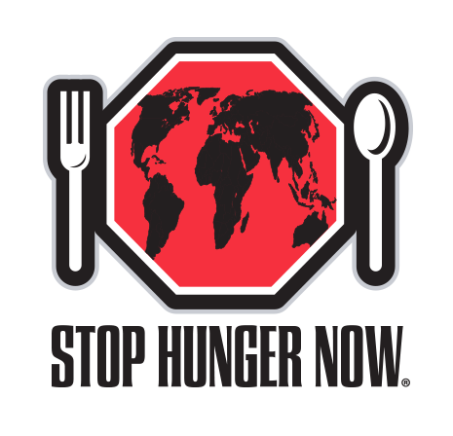
MEAL PACKAGING EVENT
SATURDAY, OCTOBER 15, 2016 * 6 SHEA WAY, NEWARK
JOIN ROTARIANS FROM AREA 10 TO PACKAGE 35,000 MEALS
UNLOAD AND SET UP 7:30 AM
PACKAGING EVENT 8:30 AM
TEAR DOWN & CLEAN UP 10:30 AM
Your help is needed for this VERY important and fun event * Sign up in Lobby or (office@rotarywilmington.org)

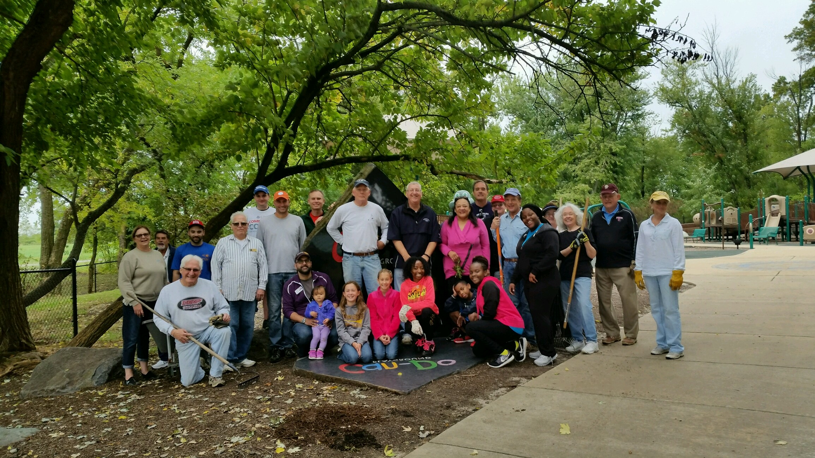
John Callahan, Ted Geist, Bill Jeremiah (daughters, Baker & Mallory), Kai Lassen,
Ralph Marshall (wife, Stephanie, son, Jack), Cynthia Morgan, Steve Novack (wife, Pat)
Interactors: Kayla Davis, Sarena James, Destinee Lampkin

Minutes for Meeting of September 29, 2016
President Kai Lassen called the meeting to order at 12:10pm at the Hotel du Pont’s du Barry Room. The Club joined together in singing “My Country ‘Tis of Thee” led by Carrie Gray with Elizabeth Rhoads on the piano. Rich Williams provided the invocation. Announcements: President Kai welcomed several guests. President Kai called on Susan Polikoff, who introduced our newest club member, Steve Novack – welcome, Steve! President Kai called on numerous club members who made the following announcements: John Matarese – volunteers are needed for the Can-Do Clean Up on Saturday, October 8 from 8:30 to 10:30am – sign up and directions to the playground are in the lobby; Sheerin Javed – volunteers are needed for Stop Hunger Now, Saturday, October 15 at 8:30am; Cindy Campanella – there are two openings for Rotary Leadership Institute on Saturday, October 22; Marilyn Whittington – 25 tickets are available for the 87’ers basketball outing on Saturday, November 12th at the University of Delaware; Tim Lyons – Rotarians and guests are invited to “Coffee Talk” on Wednesday, October 19th from 8:00 – 9:30am at the Greenville Brew HaHa!; and President Kai – charitable contribution letters were mailed last week and invoices were sent yesterday.
Program: As part of the introduction of the program, the Club joined together in singing “Forget About,” led by Michael Arrington, who also played the piano. Matt Beardwood provided the introduction of the speaker, Terry Holt, Partner, HDMK. Terry offered his perspective on the upcoming election. He mentioned that elected officials and government employees in Washington, D.C are in a holding pattern until after the election, when they will begin to strategize on a plan to work with the new legislative branch. He shared that last year, more than 50% of Americans believed Hillary Clinton was unelectable. The vast majority of Americans are dreading the election next month and both parties have expressed great concern if the other party wins. Our current situation is that we have a diffused anti-policy campaign and we are forced to choose between two very unpopular candidates and we do not like our choices. Terry mentioned that the latest average of the national polls report that Clinton is ahead by 48% and Trump is trailing by 44%. Clinton is leading in the battleground states and Trump is faring better in areas with blue-collar, white, older voters. The next President will be elected by less than half of the population. Regarding voting next month, it will be a matter of who decides to vote. The winning candidate needs 270 electoral votes and Clinton appears to have 235 – 240 of these locked up compared to Trump’s 115. The first debate resulted in an increase in Clinton’s numbers. President Obama is energizing young voters and it can be an advantage to a candidate by being close to the President. Terry provided a perspective on Congress and the Senate. People will most likely vote for Senatorial candidates independent of who’s running for Congress. He advised us that more Republicans are running for re-election than Democrats. Based on the outcome, if Clinton wins, she may be working with a House and Senate Republican Majority. Currently there are 226 safe Republicans in the House and a party needs 218 seats to win the majority. There are currently 187 safe Democrats and there are 22 seats that are competitive. Regarding the Senate, there are 47 safe Democrats and 46 safe Republicans. Ultimately, our new President will have two choices: work with Congress on an agenda that matters or invoke President Obama’s current strategy, which is to lead by regulation in lieu of being dedicated to having a good relationship with Congress The meeting ended at 1:30 pm. Respectfully submitted, Cindy Campanella, Secretary
September 28, 2016 Board Meeting (Minutes Highlights)
Tom Porth reviewed the financial statements and announced that all reports are in good condition. Tom reported that the performance of Vanguard is on target with the index (~7%). President Kai reported that we closed the month with 204 members. There were multiple Committee and Board Representative reports and items of notable mention were: Centennial Park Programming – a total of eight education stations are approved and three will be installed soon in various undisturbed sections of the park; Youth Services – the mentoring program is being led this year by Youth Services, the STEPS project is going well, and the Interact Club meeting at Howard High School held its first meeting with good turnout; Connections & Outreach – the committee is researching various options for club activities so stay tuned!; Centennial Park Service Gateway Project is moving forward albeit, largely due to DelDot's slow schedule. Respectfully submitted, Cindy Campanella, Secretary


ROTARY LEADERSHIP INSTITUTE – ONLY 1 SPOT AVAILABLE
SATURDAY, OCTOBER 22 8:30-4:30
NORTH EAST, MD
CONTACT SUE TO SIGN UP
COMMITTEE MEETINGS / DATES / EVENT
October 15 Strike Out Hunger, DE Industrial Park, Newark, 8:30am
October 19 Coffee Talk, Brew Ha Ha, Greenville, 8-9:30am
October 22 Rotary Leadership Institute, North East, MD, 8:30-4:30
October 27 Program Committee
November 12 Family Fun, 87ers, UofD, 6pm
November 19 Rotary Foundation Dinner, Dover, 5:30pm

